1. 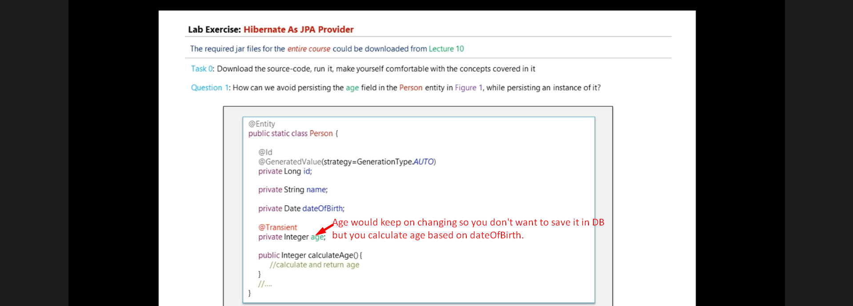
2. NOTE: Use @Transient to avoid persisting a property value into DB.